Acceptance Test Data Sheets

For

Skyryse Flight OS LEMA TPX 325

|  |  |
| --- | --- |
| LEMA Assembly Part Number | Serial Number |
|  | 12 |

6.1. **Visual Examination of the Product**

Case of units coming from field without a rig bar, do we need to include a manual rig to get it close

|  |  |
| --- | --- |
| UUT conforms to the requirements of paragraph 6.1 | True |

6.2 **Weight**

|  |  |
| --- | --- |
| UUT weight should not exceed 10 lbs | actual weight 6 lbs |

**6.3 Bonding**

Bonding resistance

|  |  |  |  |  |
| --- | --- | --- | --- | --- |
|  | **Expected** | **Tolerance** | **Simplex** | **Duplex** |
|  | (mOhms) | (mOhms) | (mOhms) | (mOhms) |
| Motor End Cap | 2.5 mOhms | 0.5 mOhms | 0 mOhms | 0 mOhms |
| Solenoid housing | 2.5 mOhms | 0.5 mOhms | 0 mOhms | 0 mOhms |
| Encoder cover | 2.5 mOhms | 0.5 mOhms | 0 mOhms | 0 mOhms |

6.4 Resistance and Inductance Test (motor and solenoid)

**Resistances:**

|  |  |  |  |  |  |
| --- | --- | --- | --- | --- | --- |
|  | **Expected** | **Tolerance** | **Connector J1** | **Connector J2** | **Connector J3** |
| Pins | Resistance (Ohms) | Resistance (Ohms) | Resistance (Ohms) | Resistance (Ohms) | Resistance (Ohms) |
| E to F | 0.212 mOhms | 0.0212 mOhms | 0 mOhms | 0 mOhms | 0 mOhms |
| F to G | 0.212 mOhms | 0.0212 mOhms | 0 mOhms | 0 mOhms | 0 mOhms |
| G to E | 0.212 mOhms | 0.0212 mOhms | 0 mOhms | 0 mOhms | 0 mOhms |
| A to L | 6.55 mOhms | 0.44 mOhms | 0 mOhms | 0 mOhms | 0 mOhms |
| G,F,E,A,L tied together to chassis grounds. Apply 500VDC | 5000000 mOhms | 0 mOhms | 0 mOhms | 0 mOhms | 0 mOhms |

**Inductances:**

|  |  |  |  |  |  |
| --- | --- | --- | --- | --- | --- |
|  | **Expected** | **Tolerance** | **Connector J1** | **Connector J2** | **Connector J3** |
|  |  |  | Inductance(mH) | Inductance(mH) | Inductance(mH) |
| E to F | 0.155 mH | 0.02325 mH | 0 mH | 0 mH | 0 mH |
| F to | 0.155 mH | 0.02325 mH | 0 mH | 0 mH | 0 mH |
| G to E | 0.155 mH | 0.02325 mH | 0 mH | 0 mH | 0 mH |
| A to L | 22 mH | 3.3 mH | 0 mH | 0 mH | 0 mH |

6.5 **Power ON UUT Checks**

Confirm all sensors are reporting nominal values and no faults reported

Delete? Does this matter before power

|  |  |  |
| --- | --- | --- |
| Sensor | Value | Pass/Fail |
| Motor 1 | 0 | Pass |
| Motor 2 | 0 | Pass |
| Motor 3 | -0.0046 | Pass |
| M1 | -34 | Failed |
| M2 | -69 | Failed |
| M3 | -53 | Failed |
| Faults 1 | 1024 | Pass |
| Faults 2 | 1024 | Pass |
| Faults 3 | 1024 | Pass |

6.7 **Functional Check Out**

6.7.1 **MCE1, MCE 2, MCE3 Power Up**

|  |  |  |  |
| --- | --- | --- | --- |
| Description | Ballnut position | Pass/Fail | |
| MCE 1 reports values for Ballnut position and motor current | 0 | Ballnut Position | Current |
| Pass | Unhandled Type: Void |
| (Simulated) FCC/reports values for M1(QPS) | -34 | Failed | Unhandled Type: Void |
| MCE 2 reports values for Ballnut position and motor current | 0 | Pass | Unhandled Type: Void |
| (Simulated) FCC/reports values for M2(QPS) | -69 | Failed | Unhandled Type: Void |
| MCE 3 reports values for Ballnut position and motor current | 0.0012 | Pass | Unhandled Type: Void |
| (Simulated) FCC/reports values for M3(QPS) | -53 | Failed | Unhandled Type: Void |

6.7.2 **N1 and N2 Extend Mechanical Stops and MCE Rigging**

**CALIBRATION ADDITON TO MCE (NEW)**

**Step 6.7.2.1** **Extend using M1/N1**

|  |  |  |
| --- | --- | --- |
| Description | Value | Pass/Fail |
| N1 extend stop engaged (M1 current saturated) | 1024 | Pass |
| MCE 1 Motor Current 4.5 +/- 0.15 Amps | 5.9908 Amps | Failed |
| Linear Encoder Value | -0.0189 | Failed |
| N1 is Rigged | 0 | Pass |

**Step 6.7.2.2** **Extend using M2/N2**

|  |  |  |
| --- | --- | --- |
| Description | Value | Pass/Fail |
| N2 extend stop engaged (M2 current saturated) | 1024 | Pass |
| MCE2 Motor Current 4.5 +/- 0.15 Amps | 6.0097 Amps | Failed |
| Linear Encoder Value | -0.085 | Pass |
| N2 (Motor 2) is Rigged | 0 | Pass |
| N2 (Motor 3) is Rigged | 0 | Pass |

6.7.3 **N1 and N2 Stroke Check**

|  |  |  |
| --- | --- | --- |
| Pin to pin Length is 16.732 +/- TBD (ins) | Pin to Pin Length | Pass/Fail |
|  |  |
| Description | Actual Position N1/N2 | Pass/Fail |
| N2 at -0.575 ins from Null using M2 | -0.575 | Pass |
| N1 at +1.725 ins from Null using M1 | 1.7245 | Pass |
| N1 at -0.575 ins from Null using M1 | -0.575 | Pass |
| N2 at +1.725 ins from NULL using M2 | 1.7262 | Pass |
| N1 at -0.575 ins from Null using M1 | -0.575 | Pass |
| N2 at +1.725 ins from Null using M3 | 1.7244 | Pass |
| N2 at -0.575 ins from Null using M3 | -0.5733 | Pass |

MOTOR 1

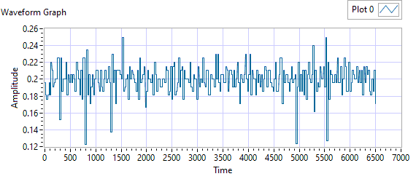

Figure - Ballnut Velocity for Motor One

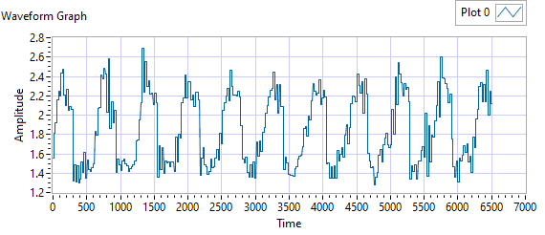

Figure -Current for Motor One

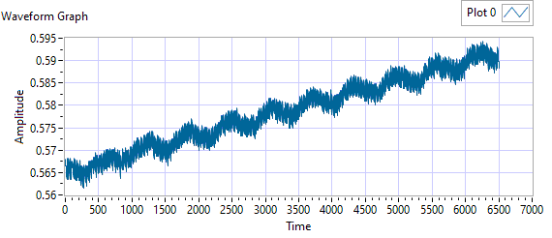

Figure - M1 Delta for Motor One

|  |  |  |  |  |  |
| --- | --- | --- | --- | --- | --- |
| **Description** | **Expected** | **Tolerance** | **Actual Average** | **Peak Velocity** | **Pass/Fail** |
| Constant Velocity | 0.2 | 0.02 | 0.2 | 0.2497 | Failed |
| **Description** | **Expected** | **Tolerance** | **Actual** | **Standard Deviation** | **Pass/Fail** |
| Delta between Motor 1 Position and M1 position | 0.1 | 0.2 | 35.598 | 0.0079 | Failed |
| Delta between Motor 1 Position and Linear Encoder position | 0.1 | 0.2 | 0.5944 | 0.3756 | Failed |
| Motor Current |  |  | 1.8483 | 0.3645 |  |

|  |  |  |  |  |
| --- | --- | --- | --- | --- |
| Description | Expected Difference from Test rig encoder | Tolerance | Difference from Test rig encoder | Pass/Fail |
| Motor 1 position + Motor 2 position = test rig encoder | 0 | 0.1 | 0.0034 | Pass |
| Motor1 position + Motor 3 position = test rig encoder | 0 | 0.1 | 0.0034 | Pass |
| M1 position + M2 position = test rig encoder | 0.1 | 0.1 | -103.3712 | Failed |
| M1 position + M3 position = test rig encoder | 0 | 0.1 | -87.3712 | Failed |
| Difference between Motor 2 position and Motor 3 position is < TBD ins | 0 | 0.1 | 0 | Pass |
| Difference between M2 position and M3 position is < TBD ins | 0 | 0 | 16 | Failed |
| Difference between Motor 1 position and M1 position is < TBD ins | 0 | 0.1 | 34.9496 | Failed |
| Difference between Motor 2 position and M2 position is < TBD ins | 0 | 0.1 | 68.425 | Failed |
| Difference between Motor 3 position and M3 position is < TBD ins | 0 | 0.1 | 52.425 | Failed |

MOTOR 2

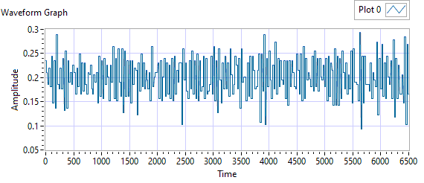

Figure - Ballnut Velocity for Motor Two

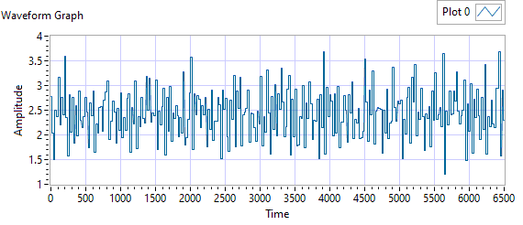

Figure -Current for Motor Two

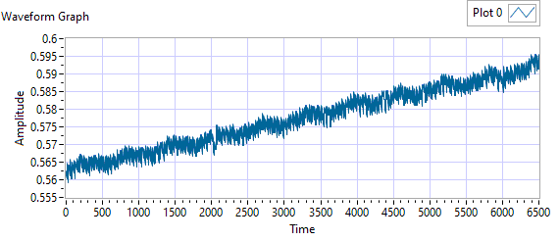

Figure - M1 Delta for Motor Two

|  |  |  |  |  |  |
| --- | --- | --- | --- | --- | --- |
| **Description** | **Expected** | **Tolerance** | **Actual Average** | **Peak Velocity** | **Pass/Fail** |
| Constant Velocity | 0.2 | 0.02 | 0.2006 | 0.2937 | Failed |
| **Description** | **Expected** | **Tolerance** | **Actual** | **Standard Deviation** | **Pass/Fail** |
| Delta between Motor 2 Position and M2 position | 0.1 | 0.2 | 70.5971 | 0.0087 | Failed |
| Delta between Motor 2 Position and Linear Encoder position | 0.1 | 0.2 | 0.5959 | 0.3753 | Failed |
| Motor Current |  |  | 2.4323 | 0.4812 |  |

|  |  |  |  |  |
| --- | --- | --- | --- | --- |
| Description | Expected Difference from Test rig encoder | Tolerance | Difference from Test rig encoder | Pass/Fail |
| Motor 1 position + Motor 2 position = test rig encoder | 0 | 0.1 | 0.0025 | Pass |
| Motor1 position + Motor 3 position = test rig encoder | 0 | 0.1 | 0.0024 | Pass |
| M1 position + M2 position = test rig encoder | 0.1 | 0.1 | -103.3569 | Failed |
| M1 position + M3 position = test rig encoder | 0 | 0.1 | -87.3569 | Failed |
| Difference between Motor 2 position and Motor 3 position is < TBD ins | 0 | 0.1 | 0.0016 | Pass |
| Difference between M2 position and M3 position is < TBD ins | 0 | 0 | 16 | Failed |
| Difference between Motor 1 position and M1 position is < TBD ins | 0 | 0.1 | 33.425 | Failed |
| Difference between Motor 2 position and M2 position is < TBD ins | 0 | 0.1 | 69.9343 | Failed |
| Difference between Motor 3 position and M3 position is < TBD ins | 0 | 0.1 | 53.9342 | Failed |

MOTOR 3

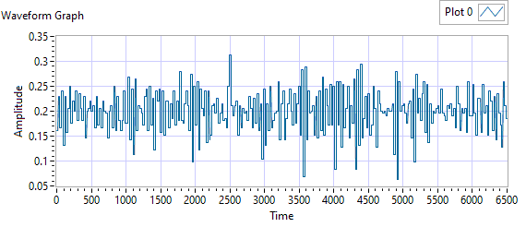

Figure - Ballnut Velocity for Motor Three

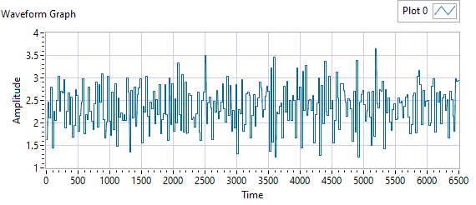

Figure -Current for Motor Three



Figure - M3 Delta for Motor Three

|  |  |  |  |  |  |
| --- | --- | --- | --- | --- | --- |
| **Description** | **Expected** | **Tolerance** | **Actual Average** | **Peak Velocity** | **Pass/Fail** |
| Constant Velocity | 0.2 | 0.02 | 0.1998 | 0.3133 | Failed |
| **Description** | **Expected** | **Tolerance** | **Actual** | **Standard Deviation** | **Pass/Fail** |
| Delta between Motor 3 Position and M3 position | 0.1 | 0.2 | 54.5857 | 0.0087 | Failed |
| Delta between Motor 3 Position and Linear Encoder position | 0.1 | 0.2 | 0.5956 | 0.3754 | Failed |
| Motor Current |  |  | 2.3578 | 0.471 |  |

|  |  |  |  |  |
| --- | --- | --- | --- | --- |
| Description | Expected Difference from Test rig encoder | Tolerance | Difference from Test rig encoder | Pass/Fail |
| Motor 1 position + Motor 2 position = test rig encoder | 0 | 0.1 | 0.0026 | Pass |
| Motor1 position + Motor 3 position = test rig encoder | 0 | 0.1 | 0.0026 | Pass |
| M1 position + M2 position = test rig encoder | 0.1 | 0.1 | -103.3711 | Failed |
| M1 position + M3 position = test rig encoder | 0 | 0.1 | -87.3711 | Failed |
| Difference between Motor 2 position and Motor 3 position is < TBD ins | 0 | 0.1 | 0.0012 | Pass |
| Difference between M2 position and M3 position is < TBD ins | 0 | 0 | 16 | Failed |
| Difference between Motor 1 position and M1 position is < TBD ins | 0 | 0.1 | 33.425 | Failed |
| Difference between Motor 2 position and M2 position is < TBD ins | 0 | 0.1 | 69.9487 | Failed |
| Difference between Motor 3 position and M3 position is < TBD ins | 0 | 0.1 | 53.9487 | Failed |

**6.7.4 Brake Release Test**

**Step d –** LEMA reaches commanded position

|  |  |  |  |  |
| --- | --- | --- | --- | --- |
| Description | Expected | Tolerance | Position | Pass/Fail |
| MCE1 /Motor 1 +/- TDB inches |  |  | 2 | Failed |
| MCE2 /Motor 2 |  |  | 2 | Failed |

**6.7.5 Performance Test – unloaded operation (one channel operation)**

**6.7.5.1.1 MCE 1 - Step Response Test**

**The result for motor one is shown below:**

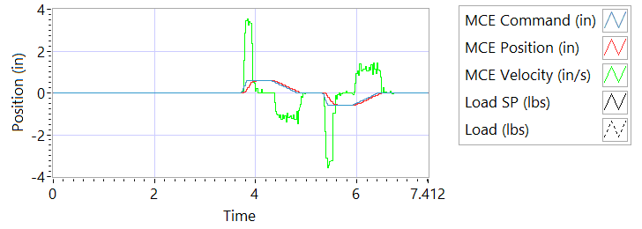

Figure - Results for Motor One

**Step d Extension**

|  |  |  |
| --- | --- | --- |
| Description | Actual Speed / Time | Pass/Fail |
| No Load speed is 2.7 to 3.3 in/sec | 3.3169 | Failed |
| Time to achieve 80% of the specified stroke (+ 0.575 ins) is 170+9/-9 ms seconds | 182 | Failed |

**Step e Retraction**

|  |  |  |
| --- | --- | --- |
| Description | Actual Speed / Time | Pass/Fail |
| No Load speed is 2.7 to 3.3 in/sec | -0.0029 | Failed |
| Time to achieve 80% of the specified stroke (- 0.575 ins) is 170+9/-9 ms seconds | 703 | Failed |

**6.7.5.1.2 MCE 1 - Frequency Response**

**Step d**

**Frequency Response**

|  |  |  |  |
| --- | --- | --- | --- |
| **Frequency** | **Phase** | **Max phase** | **Pass/Fail** |
| 0.1 Hz |  |  |  |
| 0.5 Hz |  |  |  |
| 1 Hz |  |  |  |
| 2 Hz |  |  |  |
| 3 Hz |  |  |  |
| 4 Hz |  |  |  |
| 5 Hz |  |  |  |

6.7.5.2.1 **MCE 2 - Step Response Test**

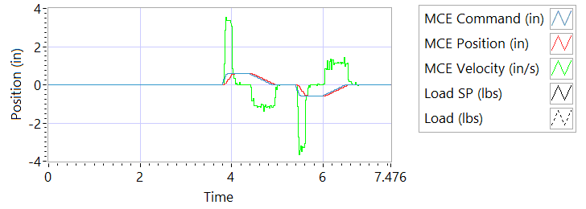

Figure - Results for Motor Two

**Step d Extension**

|  |  |  |
| --- | --- | --- |
| Description | Actual Speed / Time | Pass/Fail |
| No Load speed is 2.7 to 3.3 in/sec | 3.162 | True |
| Time to achieve 80% of the specified stroke (+ 0.575 ins) is 170+9/-9 ms seconds | 174 | True |

**Step e Retraction**

|  |  |  |
| --- | --- | --- |
| Description | Actual Speed / Time | Pass/Fail |
| No Load speed is 2.7 to 3.3 in/sec | -0.0022 | Failed |
| Time to achieve 80% of the specified stroke (- 0.575 ins) is 170+9/-9 ms seconds | 703 | Failed |

6.7.5.2.2 **MCE 2 - Frequency Response Test**

**Step d**

**Frequency Response**

|  |  |  |  |
| --- | --- | --- | --- |
| **Frequency** | **Phase** | **Max phase** | **Pass/Fail** |
| 0.1 Hz |  |  |  |
| 0.5 Hz |  |  |  |
| 1 Hz |  |  |  |
| 2 Hz |  |  |  |
| 3 Hz |  |  |  |
| 4 Hz |  |  |  |
| 5 Hz |  |  |  |

6.7.5.3.1 **MCE 3 – Step Response Test**



Figure - Results for Motor Three

**Step d Extension**

|  |  |  |
| --- | --- | --- |
| Description | Actual Speed / Time | Pass/Fail |
| No Load speed is 2.7 to 3.3 in/sec | NaN | Failed |
| Time to achieve 80% of the specified stroke (+ 0.575 ins) is 170+9/-9 ms seconds | 1 | Failed |

**Step e Retraction**

|  |  |  |
| --- | --- | --- |
| Description | Actual Speed / Time | Pass/Fail |
| No Load speed is 2.7 to 3.3 in/sec | -0.0001 | Failed |
| Time to achieve 80% of the specified stroke (+ 0.575 ins) is 170+9/-9 ms seconds | 928 | Failed |

6.7.5.3.2 **MCE 3 Frequency Response Test**

**Step d**

|  |  |  |  |
| --- | --- | --- | --- |
| **Frequency** | **Phase** | **Max phase** | **Pass/Fail** |
| 0.1 Hz |  |  |  |
| 0.5 Hz |  |  |  |
| 1 Hz |  |  |  |
| 2 Hz |  |  |  |
| 3 Hz |  |  |  |
| 4 Hz |  |  |  |
| 5 Hz |  |  |  |

6.7.6 **Performance Test – Loaded Operation**

6.7.6.1 **Step and Frequency Response Test - Loaded**

6.7.6.1.1 **MCE1 – Step Response Test**

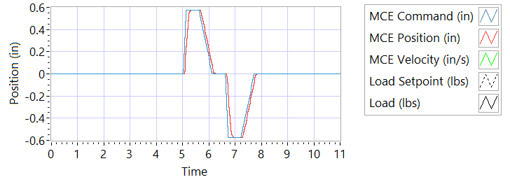

Figure - Results for Motor One Loaded

Step response Test

**Step j – 225 lbf tension**

|  |  |  |
| --- | --- | --- |
| Description | Actual Value | Pass/Fail |
| speed between 2.07 and 2.53 in/sec | 3.1864 | True |
| Time to achieve 80% of the specified stroke (+ 0.575 ins) is 170 +9/-9 ms | 179 | True |

**Step k – 225 lbf tension**

|  |  |  |
| --- | --- | --- |
| Description | Actual Value | Pass/Fail |
| speed between 2.07 and 2.53 in/sec | -0.0093 | Failed |
| Time to achieve 80% of the specified stroke (- 0.575 ins) is 170 +9/-9 ms | 733 | Failed |

**Step n – 225 lbf compression**

|  |  |  |
| --- | --- | --- |
| Description | Actual Value | Pass/Fail |
| speed between 2.07 and 2.53 in/sec | 2.8509 | True |
| Time to achieve 80% of the specified stroke (+ 0.575 ins) is 170 +9/-9 ms | 208 | Failed |

**Step o – 225 lbf compression**

|  |  |  |
| --- | --- | --- |
| Description | Actual Value | Pass/Fail |
| speed between 2.07 and 2.53 in/sec | -3.0605 | Failed |
| Time to achieve 80% of the specified stroke (- 0.575 ins) is 170 +9/-9 ms | 192 | Failed |

6.7.6.1.2 **MCE 1 – Frequency Response Test**

**Step d – 225 lbf Tension**

|  |  |  |  |
| --- | --- | --- | --- |
| **Frequency** | **Phase** | **Max phase** | **Pass/Fail** |
| 0.1 Hz |  |  |  |
| 0.5 Hz |  |  |  |
| 1 Hz |  |  |  |
| 2 Hz |  |  |  |
| 3 Hz |  |  |  |
| 4 Hz |  |  |  |
| 5 Hz |  |  |  |

**Step h – 225 lbf Compression**

|  |  |  |  |
| --- | --- | --- | --- |
| **Frequency** | **Phase** | **Max phase** | **Pass/Fail** |
| 0.1 Hz |  |  |  |
| 0.5 Hz |  |  |  |
| 1 Hz |  |  |  |
| 2 Hz |  |  |  |
| 3 Hz |  |  |  |
| 4 Hz |  |  |  |
| 5 Hz |  |  |  |

6.7.6.1.3 **MCE 2 – Step Response Test**

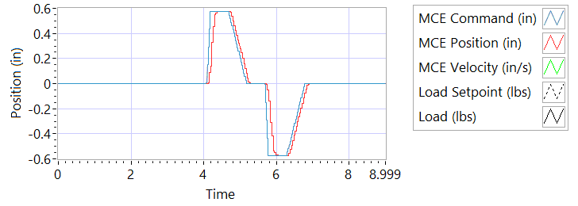

Figure - Results for Motor Two Loaded

**Step j – 225 lbf tension**

|  |  |  |
| --- | --- | --- |
| Description | Actual Value | Pass/Fail |
| speed between 2.07 and 2.53 in/sec | 3.2565 | True |
| Time to achieve 80% of the specified stroke (+ 0.575 ins) is 170 +9/-9 ms | 170 | True |

**Step k – 225 lbf tension**

|  |  |  |
| --- | --- | --- |
| Description | Actual Value | Pass/Fail |
| speed between 2.07 and 2.53 in/sec | -0.0094 | Failed |
| Time to achieve 80% of the specified stroke (- 0.575 ins) is 170 +9/-9 ms | 725 | Failed |

**Step n – 225 lbf compression**

|  |  |  |
| --- | --- | --- |
| Description | Actual Value | Pass/Fail |
| speed between 2.07 and 2.53 in/sec | 2.9483 | True |
| Time to achieve 80% of the specified stroke (+ 0.575 ins) is 170 +9/-9 ms | 198 | Failed |

**Step o – 225 lbf compression**

|  |  |  |
| --- | --- | --- |
| Description | Actual Value | Pass/Fail |
| speed between 2.07 and 2.53 in/sec | -0.0022 | Failed |
| Time to achieve 80% of the specified stroke (- 0.575 ins) is 170 +9/-9 ms | 702 | Failed |

6.7.6.1.4 **MCE 2 – Frequency response Test**

**Step d – 225 lbf Tension**

|  |  |  |  |
| --- | --- | --- | --- |
| **Frequency** | **Phase** | **Max phase** | **Pass/Fail** |
| 0.1 Hz |  |  |  |
| 0.5 Hz |  |  |  |
| 1 Hz |  |  |  |
| 2 Hz |  |  |  |
| 3 Hz |  |  |  |
| 4 Hz |  |  |  |
| 5 Hz |  |  |  |

**Step h – 225 lbf Compression**

|  |  |  |  |
| --- | --- | --- | --- |
| **Frequency** | **Phase** | **Max phase** | **Pass/Fail** |
| 0.1 Hz |  |  |  |
| 0.5 Hz |  |  |  |
| 1 Hz |  |  |  |
| 2 Hz |  |  |  |
| 3 Hz |  |  |  |
| 4 Hz |  |  |  |
| 5 Hz |  |  |  |

6.7.6.1.5 **MCE 3 – Step Response Test**



Figure - Results for Motor Three

**Step j – 225 lbf tension**

|  |  |  |
| --- | --- | --- |
| Description | Actual Value | Pass/Fail |
| speed between 2.07 and 2.53 in/sec | 2.626 | Failed |
| Time to achieve 80% of the specified stroke (+ 0.575 ins) is 170 +9/-9 ms | 223 | Failed |

**Step k – 225 lbf tension**

|  |  |  |
| --- | --- | --- |
| Description | Actual Value | Pass/Fail |
| speed between 2.07 and 2.53 in/sec | -2.2997 | Failed |
| Time to achieve 80% of the specified stroke (- 0.575 ins) is 170 +9/-9 ms | 239 | Failed |

**Step n – 225 lbf compression**

|  |  |  |
| --- | --- | --- |
| Description | Actual Value | Pass/Fail |
| speed between 2.07 and 2.53 in/sec | 2.8852 | True |
| Time to achieve 80% of the specified stroke (+ 0.575 ins) is 170 +9/-9 ms | 204 | Failed |

**Step o – 225 lbf compression**

|  |  |  |
| --- | --- | --- |
| Description | Actual Value | Pass/Fail |
| speed between 2.07 and 2.53 in/sec | -0.0029 | Failed |
| Time to achieve 80% of the specified stroke (- 0.575 ins) is 170 +9/-9 ms | 706 | Failed |

6.7.6.1.6 **MCE 3 – Frequency Response Test**

**Step d – 225 lbf Tension**

|  |  |  |  |
| --- | --- | --- | --- |
| **Frequency** | **Phase** | **Max phase** | **Pass/Fail** |
| 0.1 Hz |  |  |  |
| 0.5 Hz |  |  |  |
| 1 Hz |  |  |  |
| 2 Hz |  |  |  |
| 3 Hz |  |  |  |
| 4 Hz |  |  |  |
| 5 Hz |  |  |  |

**Step h – 225 lbf Compression**

|  |  |  |  |
| --- | --- | --- | --- |
| **Frequency** | **Phase** | **Max phase** | **Pass/Fail** |
| 0.1 Hz |  |  |  |
| 0.5 Hz |  |  |  |
| 1 Hz |  |  |  |
| 2 Hz |  |  |  |
| 3 Hz |  |  |  |
| 4 Hz |  |  |  |
| 5 Hz |  |  |  |

**6.7.7 Holding Load Test**

6.7.7.1 Brake OFF, LEMA Output Locked

|  |  |  |  |  |
| --- | --- | --- | --- | --- |
| MCE | Expected Output force, lbf | Actual Output force, lbf | Output force, Pass/Fail | Position feedback signals (all sensors) Pass/Fail |
| MCE 1, 6.7.8.1.1 step i – extend 0.2 in |  | FORCE | RESULTS | RESULTS |
| MCE 1, 6.7.8.1.1 step k - retract 0.2 in |  | FORCE | RESULTS | RESULTS |
| MCE 2, m step i – extend 0.2 in |  | FORCE | RESULTS | RESULTS |
| MCE 2, m step k - retract 0.2 in |  | FORCE | RESULTS | RESULTS |
| MCE 3 m step i – extend 0.2 in |  | FORCE | RESULTS | RESULTS |
| MCE 3 m step k - retract 0.2 in |  | FORCE | RESULTS | RESULTS |

**6.7.7.2 Brake ON, LEMA Output Free**

|  |  |  |
| --- | --- | --- |
| MCE | 12.6 +/- TBD Amps for 3-5 sec | Position feedback signals (all sensors) |
| MCE 1, 6.7.8.2.1 step I – extend 0.2 in | RESULTS | RESULTS |
| MCE 1, 6.7.8.2.1 step k - retract 0.2 in | RESULTS | RESULTS |
| MCE 2, 6.7.8.2.2 6.7.8.2.3 step i – extend 0.2 in | RESULTS | RESULTS |
| MCE 2, m step k - retract 0.2 in | RESULTS | RESULTS |
| MCE 3 m step i– extend 0.2 in | RESULTS | RESULTS |
| MCE 3 m step k - retract 0.2 in | RESULTS | RESULTS |

**6.7.7.3 Brake Release test**

**Step d –** LEMA reaches commanded position

|  |  |  |  |  |
| --- | --- | --- | --- | --- |
|  | Expected | Tolerance | Actual Position | Pass/Fail |
| MCE1 /Motor 1 |  |  |  | RESULTS |
| MCE2 /Motor 2 |  |  |  | RESULTS |

6.7.8 **Backlash**

6.7.8.1 **Simplex Brake 1 – ON; Duplex brake 2 – OFF**

|  |  |  |
| --- | --- | --- |
| Load (lbf) | Backlash (ins) | Pass/Fail |
| Step e +/- 100 lbf (motor 2 and motor 3 ZERO position) | INCHES | RESULTS |
| Step h, Total backlash | INCHES | RESULTS |
| Step f 322 lbf tension followed by 322 lbf compression | INCHES | RESULTS |
| All channels feedback signals (Motor 1, Motor 2, Motor 3, M1, M2 and M3 remain within allowable limits | INCHES | RESULTS |

6.7.8.2 **Simplex Brake 1 – OFF; Duplex Brake 2 – ON**

|  |  |  |
| --- | --- | --- |
| Load (lbf) | Backlash (ins) | Pass/Fail |
| Step e +/- 100 lbf (motor 1 holding ZERO position) | INCHES | RESULTS |
| Step h, Total backlash | INCHES | RESULTS |
| Step f, 322 lbf tension followed by 322 lbf compression | INCHES | RESULTS |
| All channels feedback signals (Motor 1, Motor 2, Motor 3, M1, M2 and M3 remain within allowable limits | INCHES | RESULTS |

6.7.8.3 **Both Brakes OFF**

|  |  |  |
| --- | --- | --- |
| Load (lbf) | Backlash (ins) | Pass/Fail |
| Step e +/- 100 lbf (both motors holding ZERO position) | INCHES | RESULTS |
| Step h, Total backlash | INCHES | RESULTS |
| Step f 322 lbf tension followed by 322 lbf compression | INCHES | RESULTS |
| All channels feedback signals (Motor 1, Motor 2, Motor 3, M1, M2 and M3 remain within allowable limits | INCHES | RESULTS |